**Timeline and Process for Parent Governor Elections**

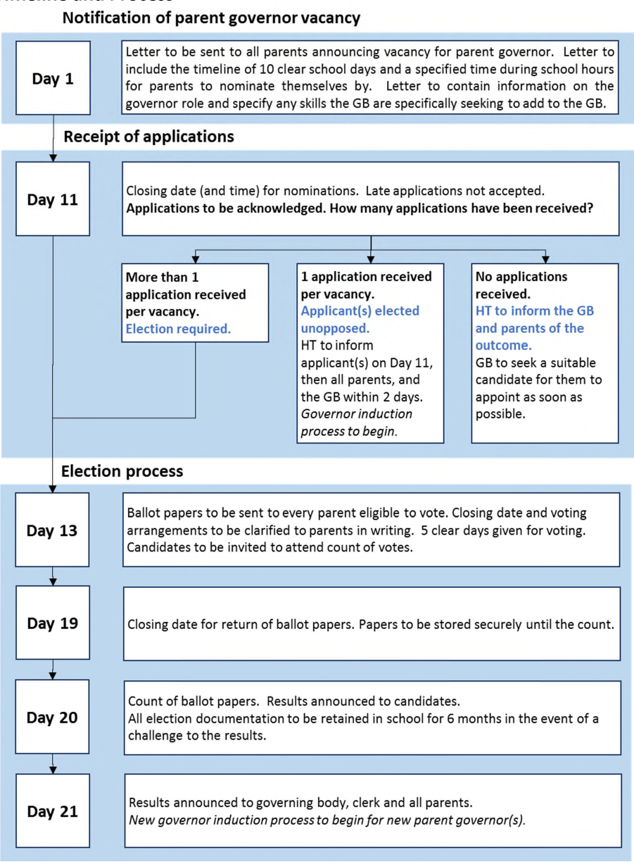

*Please note that all days are calculated on school days.

Day 1 –15th September 2023

Day 11 – 25th September 2023

Day 13 – 27th September 2023

Day 19 – 3rd October 2023

Day 20 – 4th October 2023

Day 21 – 5th October 2023